Logic Model Template
CSforALL 2024 RPP Strand

NSF GOAL: [insert the NSF solicitation goal here specific to your strand]

ALIGNED PROJECT GOAL: The goal of PROJECT NAME is to…

Intellectual Merit: How does this project advance the field and/or innovation?

Broader Impacts: What potential does it have to improve society?

REQUIRED BPC audience/alignment for CS for All:
- What are the characteristics and needs of the intended population(s) to be served?

- What are the specific plans or strategies for addressing or accommodating the particular needs of participants of the intended population(s)?

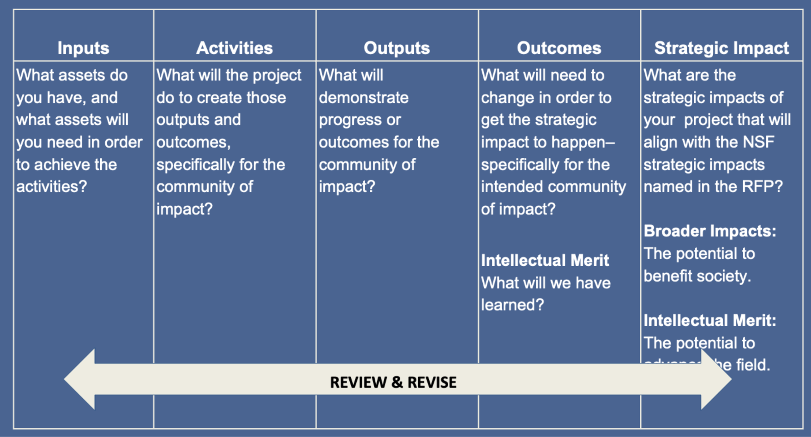

Inputs | Activities | Outputs | Outcomes | Strategic Impacts

